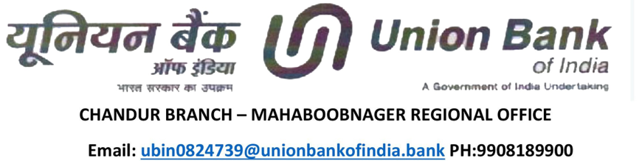

LR.NO. 24731/EL/2024-24/13 DATE: 01-06-2024

**TO WHOMSOEVER IT MAY CONCERN**

This is to Certify **Mr. AITHAGONI ANJAIAH** son of **ACHALAIAH** is having savings bank account No.247312010001926 with our bank and the credit balance in the above account as on date i.e. 01-06-2024 is Rs. **48,59,658.58/-** (Rupees Forty Eight lakhs fifty-nine thousand six hundred fifty-eight rupees and paisa fifty - eight only) which is equivalent to **USD 58255.32** @ Rs.**83.42/**- Per USD. The Funds are clearly and unconditionally available for immediate withdrawals at any given point of time.

This letter is issued at the specific request of the account holder for the higher education in USA Purpose of his son **MR.AITHAGONI SHIVA**.

